Project Initialization and Planning Phase

Date | 30 September 2026
Team ID | SWTID-2026-9887
Project Name | AI BlogNest API
Maximum Marks | 3 Marks

Define Problem Statements (Customer Problem Statement Template):
Create a problem statement to understand your customer's point of view. The Customer Problem Statement
template helps you focus on what matters to create experiences people will love. A well-articulated customer
the process, you’ll also be able to empathize with your customers, which helps you better understand how they
perceive your product or service.

Example:
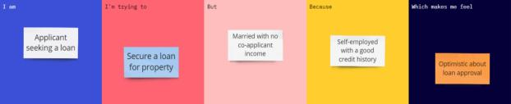

Problem  Statement  (PS) | I am  (Customer) | I’m trying  to | But | Because | Which makes  me feel
PS-1 | A male applicant seeking a loan. | Secure a loan for the  property | Married with no co-applicant income. | Self-employe  d with a good  credit history. | Optimistic about loan approval.

